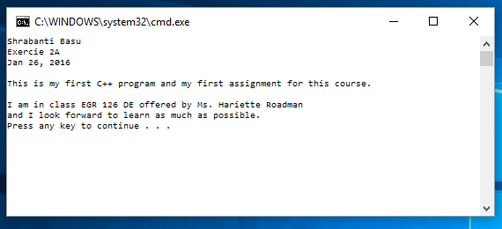

//Shrabanti Basu

//Exercise 2A

//Jan 26, 2016

/\*

The objective of this program is to write my first C++ program

using the Visual Studio IDE and to introduce myself to the environment.

\*/

#include <iostream>

using namespace std;

int main()

{

cout << "Shrabanti Basu" << endl;

cout << "Exercie 2A" << endl;

cout << "Jan 26, 2016" << endl << endl;

cout << "This is my first C++ program and my first assignment for this course." << endl << endl;

cout << "I am in class EGR 126 DE offered by Ms. Hariette Roadman\n";

cout << "and I look forward to learn as much as possible.\n";

return 0;

}